
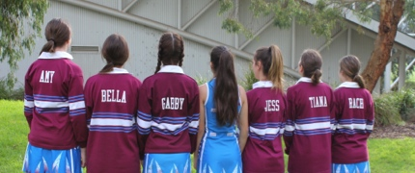
Treasurer –Mrs. Jackie McLellan
0408310395
e: jmclellam@bigpond.com

Secretary- Mrs Lisa Garlick
0402256844

President- Mrs. Margaret Barnes
3 Pontford Crt Wheelers Hill 3150
0413331220
e: margtbarnes@bigpond.com

St. Justin’s Netball Club
www.netballclubstjustins.com

SJNC




COMPULSORY UNIFORM - TUNIC
Tunic Style Dress-All Players Junior & Senior  Sample dresses are available to try on for accurate ordering on Saturdays at the courts by arrangement ONLY  All sizes children & adult 6-24 | $80

APPAREL ORDER INFORMATION

Apparel order made to:
Contact - Jodie Vaccarino 0422443529 e: thevaccas05@gmail.com (try on a sample dress prior to ordering size)
Dress collection - (by arrangement see details below)

Payment can be made through bank prior to receiving goods: EFT bank account -St Justin’s Netball Club * 083 347 *490 995 388
Ref Details: give full details

Apparel will only be given upon vision of a receipt.

- OPTIONAL
Fleecy Hooded Windcheater Colour Snow Marl (with blue SJNC embroidery Front & Sleeves)  All sizes | $45
  Short Sleeved Sublimated Polo Tops-(warm up tops) -  All sizes | $45
Rugby Top Long Sleeve (Maroon /Striped)  All sizes children’s & adults | $60
Rugby Tops Names
Arrangements made by yourself –Screen Printer MATT-130 Bridge Rd Keysborough 9769 0083

Apparel Contacts | EMAIL OR PHONE DETAILS
Apparel - Jodie Vaccarino (try on a sample dress prior to ordering size) |  | 0422443529 | thevaccas05@gmail.com
Apparel other contact –Peta Hall (dress collection by arrangement) |  | 0421332865 | peta@hallhealthcare.com.au

